**Problem 2 Part 2 Part c– Shooting method solver**

I implemented the following functions:

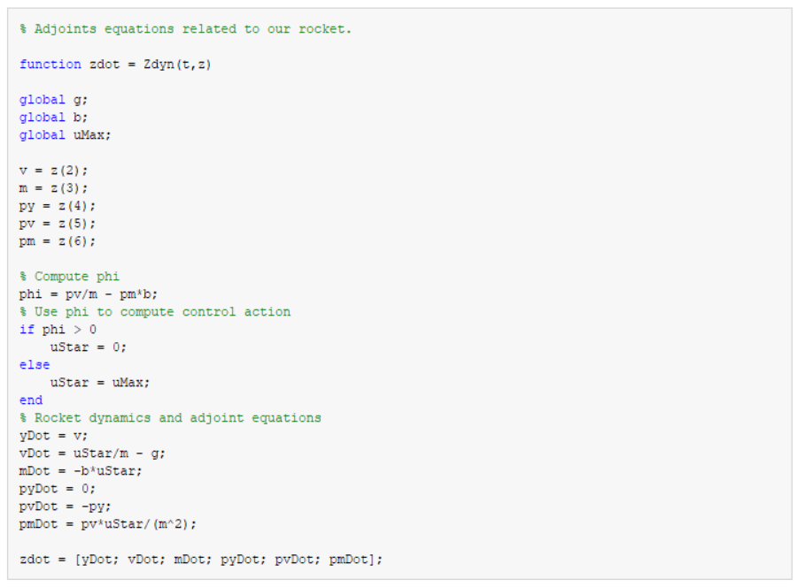

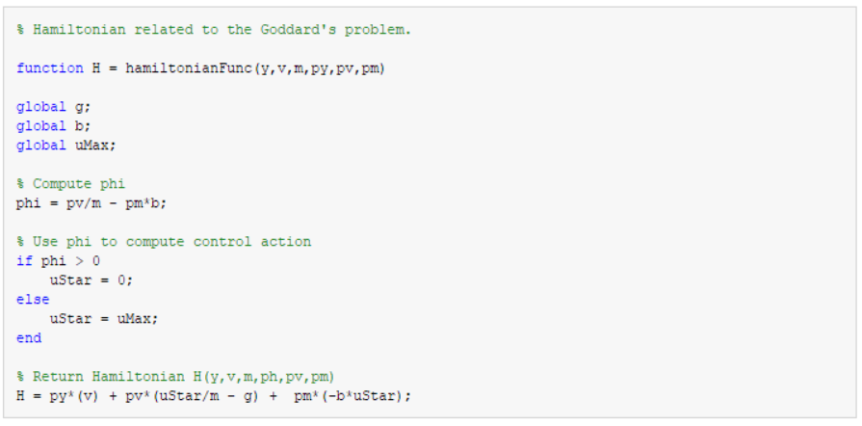

Results:

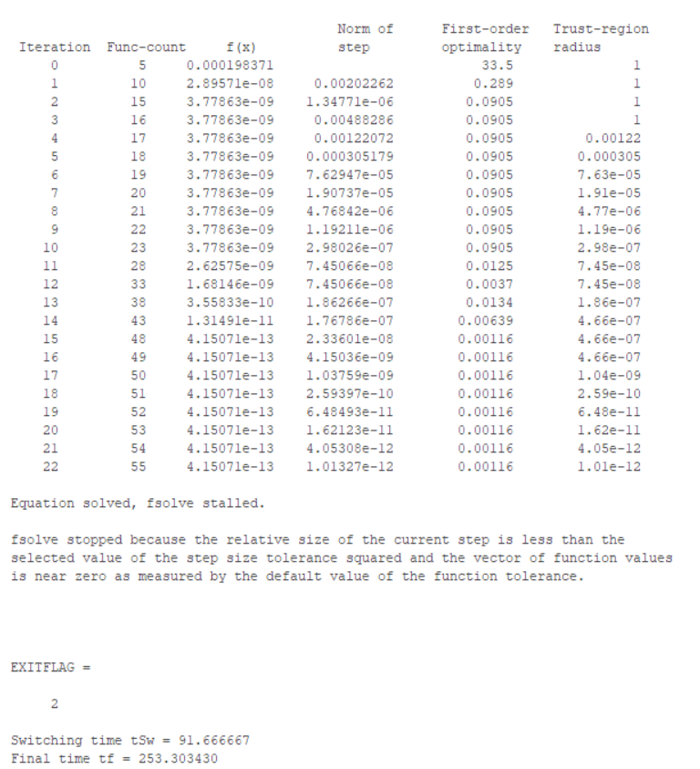

**Switching time tSw = 91.666667**

**Final time tf = 253.303430**

**These are the same results as from the dichotomy approach.**

**Problem 2 Part 2 Part d– Sensitivity of guess**

|  |  |  |
| --- | --- | --- |
| **tf guess** | **Convergence reached?** | **# of iterations** |
| tf = 253.302 | **Yes** | **22** |
| tf = 255 | **Yes** | **28** |
| tf = 270 | **No** | **n/a** |

**This shows that the shooting method is very sensitive to our guess of tf.**